1. Let 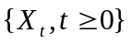 be a uniformly integrable submartingale w.r.t {ℱ,.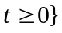.
(1) Prove that for two sequences 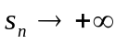 and 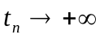, 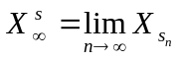 and 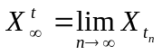 a.s. exist and 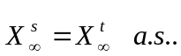
(2) Prove that 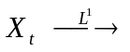some integrable 

